- DNEVI V TEDNU: Ditët e javës
WRITE DAYS IN A WEEK: PONEDELJEK, _____________, SREDA, ______________, _________________, _______________, ________________ .
- MESECI: Muaj
WRITE MONTHS:
JANUAR, FEBRUAR, _____________, ____________, MAJ, ____________, __________, AVGUST, _______________, _______________, NOVEMBER IN ___________________.

ODGOVORI (ANSWER): Ai u përgjigj
- KAKO TI JE IME?____________________________________________________
- KOLIKO SI STAR/A? _________________________________________________
- KAKO SE PIŠEŠ? _____________________________________________________
- V KATERI RAZRED HODIŠ? __________________________________________
- KAKŠNE BARVE JE TVOJA MAJICA? __________________________________
- OD KOD SI? _________________________________________________________
- KAKŠNE BARVE SO TVOJE HLAČE? ___________________________________
- KAKŠNE BARVE SO TVOJI COPATI? ___________________________________
- KAKO JE IME TVOJI UČITELJICI? ______________________________________

- POIMENUJ BARVE: NAME THE COLORS
____________________ ____________________
_____________ _________________ ________________
- KAJ JE TO? Cfare eshte ajo?
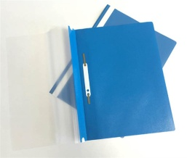 ______________ 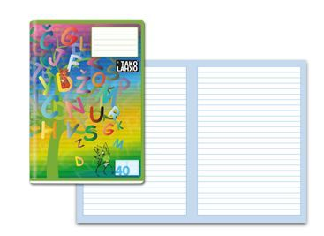__________________
__________________ ____________________
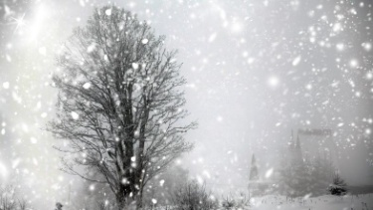 ____________ 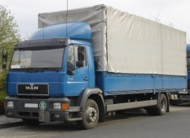 _______________ 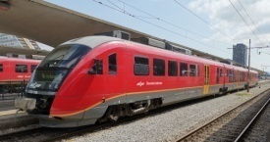 ___________ 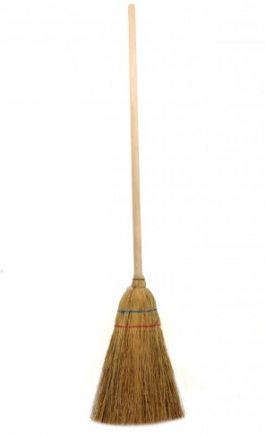 ____________ 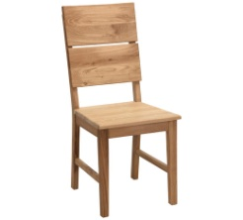
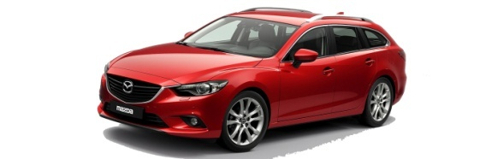_____________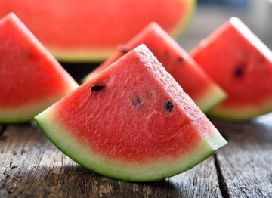 ___________
_________ _________ ________

- ODGOVORI (ANSWER): Ai u përgjigj
- KATERO JE TVOJE NAJLJUBŠE SADJE? (WHICH IS YOUR FAVORITE FRIUT?) _________________________________________________________
- KATERA JE TVOJA NAJLJUBŠA ŽIVAL? (WHICH IS YOUR FAVORITE ANIMAL?) _________________________________________________________
- KAJ NAJRAJE JEŠ? (WHAT DO YOU PREFER TO EAT?)

- KDO JE TO? Kush eshte ajo?
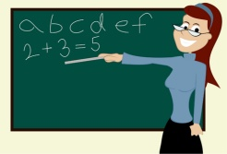 __________________ ______________
_________________ ____________
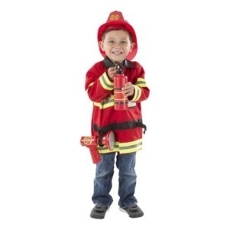 ____________ __________________
KJE DELA ZDRAVNIK? (WHERE DOES THE DOCTOR WORKS?) _______________________________________________________________________
KJE DELA UČITELJICA? (WHERE DOES THE TEACHER WORK?) _______________________________________________________________________

- NARIŠI FANTA ALI PUNCO, KI HODI, POSLUŠA GLASBO, BARVA IN IGRA NOGOMET! (DRAW A GIRL OR A BOY WHO IS WALKING, LISTENING TO MUSIC, PAINTING AND PLAYING FOOTBALL!)

- NARIŠI SVOJO DRUŽINO IN POIMENUJ ČLANE DRUŽINE: DRAW YOUR FAMILY AND NAME THE MEMBERS OF YOUR FAMILY

- NARIŠI ŽIRAFO, SLONA, MEDVEDA, VEVERICO, KRAVO IN MAČKO.

