Osnovna šola Frana Erjavca Nova Gorica Šol. leto 2019/20
2. PISNO OCENJEVANJE ZNANJA TJA
Ime in priimek: _______________________________ Št. vseh točk: 50
Razred: 7. Št. doseženih točk: _________
Ocena: ___________________
PRAGOVI MED OCENAMI:
0–22 nzd (1) | 22,5–32 zd (2) | 32,5–39,5 db (3) | 40–44,5 pdb (4) | 45–50 odl (5)
0−44 % | 45−64 % | 65−79 % | 80−89 % | 90−100 %

1. Read the ads and decide if each statement is true or false. Preberi oglase in označi, ali trditve držijo ali ne.
Yes, we’re open seven days a week!  Location: 1015 Broadway Street (next to the DVD rental shop)  Like us on Facebook and win a free movie ticket! | Jurrasic Bark  Watch these barking mad dinos go wild!  In 3D!  “Best science fiction movie of the year!” | Funny Bone  Lots of fun for the whole family!  “You’ll laugh your socks off!”  “I’m still laughing!” | Car Wars III  An “out-of-this-world” movie about … you guessed it, cars!  “Two thumbs up!”  “The action movie you can’t miss!”
 | SHOW TIMES  10:00 am 5:30 pm  12:30 pm 8:00 pm  3:00 pm | SHOW TIMES  9:30 am 4:30 pm  11:45 am 6:00 pm  1:45 pm 8:30 pm | SHOW TIMES  12:45 pm 7:30 pm  3:45 am 9:30 pm  5:30 pm
0. The movie theatre is closed on Tuesdays. TRUE / FALSE
1. ‘Car Wars III’ is an action movie. TRUE / FALSE
2. The last showing of ‘Funny Bone” is at 9:30 pm. TRUE / FALSE
3. The first showing of ‘Jurassic Bark’ is at 10:00 am. TRUE / FALSE
4. You can win a free movie ticket by going online. TRUE / FALSE
5. There aren’t any morning show times for ‘Car Wars III’. TRUE / FALSE
6. ‘Funny Bone’ is a good movie for children. TRUE / FALSE
7. One of the movies is a comedy. TRUE / FALSE
8
8. You can rent DVDs at the movie theatre. TRUE / FALSE

2. Circle the correct answers. Obkroži pravilne odgovore.

0. IF YOU WATCH A ‘COMEDY’ MOVIE OR TV SHOW, WHAT WILL YOU PROBABLY DO?

a) laugh b) cry c) buy something d) dance
1. A MOVIE OR TV ‘AUDIENCE’ ARE THE PEOPLE WHO …
a) watch a movie or TV programme b) make a movie or TV programme
c) act in a movie or TV programme d) write about a movie or TV programme
2. THE ‘CAST’ OF A MOVIE MEANS THE PEOPLE WHO….
a) watch a movie b) make a movie c) act in a movie d) write about a movie
3. WHICH OF THE FOLLOWING PROGRAMS CAN BE DESCRIBED AS A ‘DOCUMENTARY’?
a) a talk show b) a history program c) a soap opera d) a cooking show
4. WHY DO MOST PEOPLE READ MOVIE OR TV ‘SUBTITLES’?
a) to find out when a show begins b) to find out how good a movie is
c) to understand what people say d) to find out how to use a TV
5. WHAT DOES A ‘TV ADDICT’ USUALLY DO?
5
a) complains about TV programs b) fixes broken televisions
c) watches TV all day d) acts in TV programs

4
3. Look at the pictures and write the English expressions for people at a film set. Oglej si slike in zapiši angleške izraze za ljudi na filmskem prizorišču.
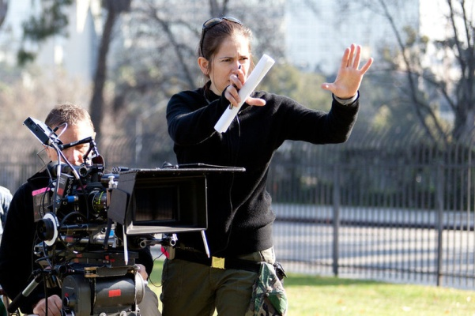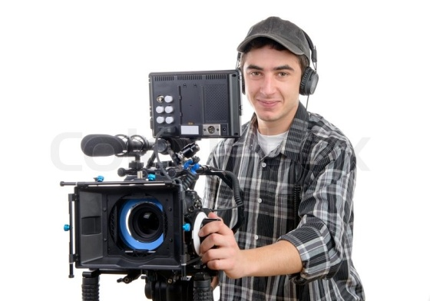
_______________________________________ ____________________________________________
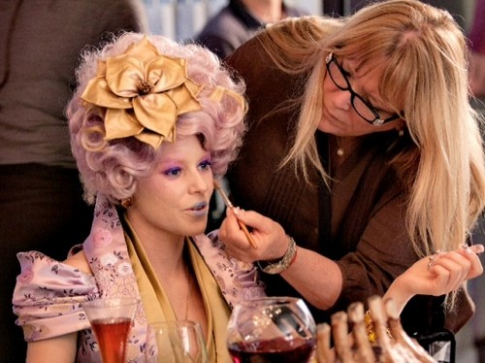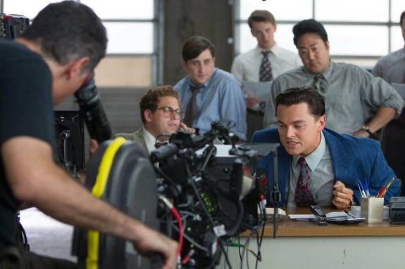
______________________________________ _______________________________________

4. Look at the chart and compare the movies. Use suitable adjectives to form at least 4 different comparisons. Oglej si tabelo in primerjaj filme. Uporabi primerne pridevnike in tvori vsaj 4 primerjave.
 | Lego Movie 2 | Green Book | The Upside
LENGTH | 106 min | 130 min | 125 min
POPULARITY
PRICE OF A TICKET | 6,5 EUR | 7 EUR | 5 EUR

1. ___________________________________________________________________________________
2. ___________________________________________________________________________________
3. ___________________________________________________________________________________
4. ___________________________________________________________________________________
4

5. Give 3 reasons why watching TV can be good for you. Write whole sentences. Naštej tri razloge, zakaj je gledanje televizije lahko dobro zate. Piši v stavkih.
_______________________________________________________________________________________________________________________________________________________________________________________________________________________________________________________________
2

6. Complete the sentences with the correct form of words in brackets. Stavke dopolni z ustrezno obliko besede v oklepaju.
0. I think that in the film “The Pursuit of Happyness” Will Smith acted __fantastically____ (fantastic).
1. Jennifer Lawrence is the most ___________________________ (beautiful) actress in the world. Besides being a very talented actress, she sings ______________________________ (beautiful) as well.
2. When I got home, I ___________________________ (quick) turned on the TV to watch my favourite soap opera.
6
3. “The Fast and the Furious” is a ___________________________ (good) film than “Batman”.
4. I really don’t like “Titanic”. The story ends so __________________________ (sad).
5. Someone ______________________________ (sudden) switched on the lights while we were watching a movie.
3
7. Match the halves of the sentences. Poveži polovice stavkov.
1 Johnny Depp’s eyes are ____ as cold as ice.
2 When we finished filming in the cold weather, my hands were ____ as dark as night.
3 The old camera we found in the attic was ____ as
4 We couldn’t see anything when we walked into the cinema hall – it was ____ as white as snow.
5 ____ as blue as the sky.
6 The beard of the old man in the movie was ____ as heavy as lead.
8. Insert the correct form of going to. Vstavi ustrezno obliko going to.
0. I ___am going to make____ (make) an interview with Brad Pitt at the film festival next Sunday.
1. They _________________________________________ (order) a pizza before they go to the cinema.
2. We _____________________________________________ (not go) to the cinema tomorrow.
3. Paul_____________________________________________ (get) a summer job in the film studio.
4. _____________________________________ (you / buy) tickets for the show tonight?
5. _________________________________________________ (Greg / start) filming a new documentary next year?
6
6. Vin Diesel and Dwayne Johnsons ________________________________ (act) in another sequel of The Fast and the Furious together.

9. Complete the interview with Brad Pitt. Dopolni intervju z Brad Pittom.
Interviewer: Thank you for taking some time off from your busy schedule to answer a few questions about your life!
Brad: It's my pleasure.
Interviewer: Could you tell us about an average day in your life?
Brad: Sure, I _get up__ (get up) early - at 7 in the morning. Then I ___________________ (have) breakfast. After breakfast, I go to the gym.
Interviewer: ________________________________________ (you / study) and preparing for a movie now?
Brad: Yes, I ____________________________ (learn) a new film called "The Man About Town".
Interviewer: What __________________________________________ (you / do) in the afternoon?
Brad: First I have lunch, then I _____________ (go) to the studio and shoot some scenes.
Interviewer: You ____________________ (make) a very successful film last year – War Machine. Was it difficult to act and direct at the same time?
Brad: Yes, I must say it __________ (be) quite challenging. But I ______________________ (learn) a lot. I ________________________ (not sleep) a lot last year because I was afraid to let others down. But, at the end, the film was successful and people ____________________ (like) it – so, this is what matters the most!
Interviewer: What about your plans for the future?
12
Brad: Well, I try not to think about future too much. I can tell you that next week __________________________________________________ (take) my children to Greece. Then we __________________________________________ (travel) around Europe for a while – I can’t wait!

