7. A
Monday, 6th April – Thursday, 9th April
Good morning to all the happy bunnies out there!
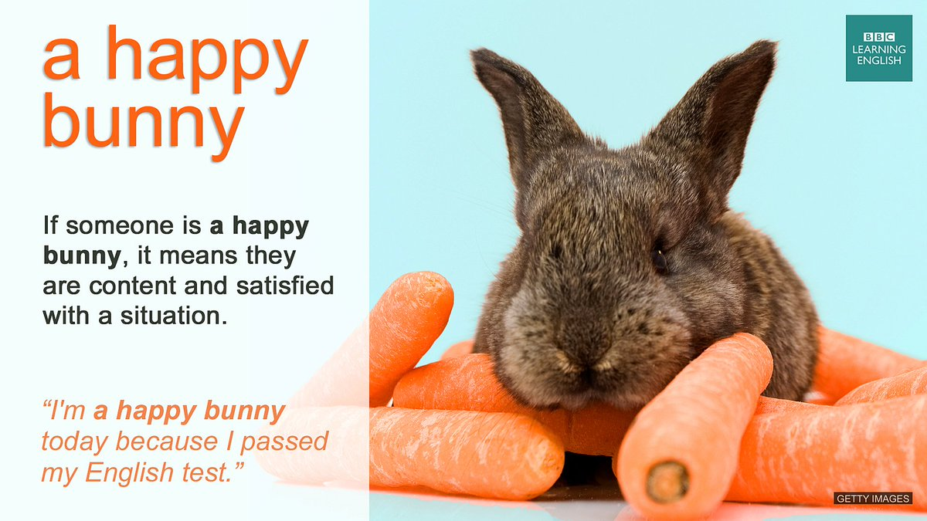
If you are not a happy bunny yet, then think of something that is good in your current situation, try to find something that makes you happy, and become a happy bunny!
Why did I post the picture of a bunny? Can you guess? Well, Easter is here.
Think of some Slovene traditional dishes and food during Easter. What about traditional British Easter food? Do you know any? Do you know what those are?
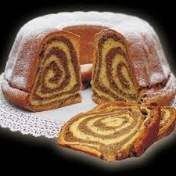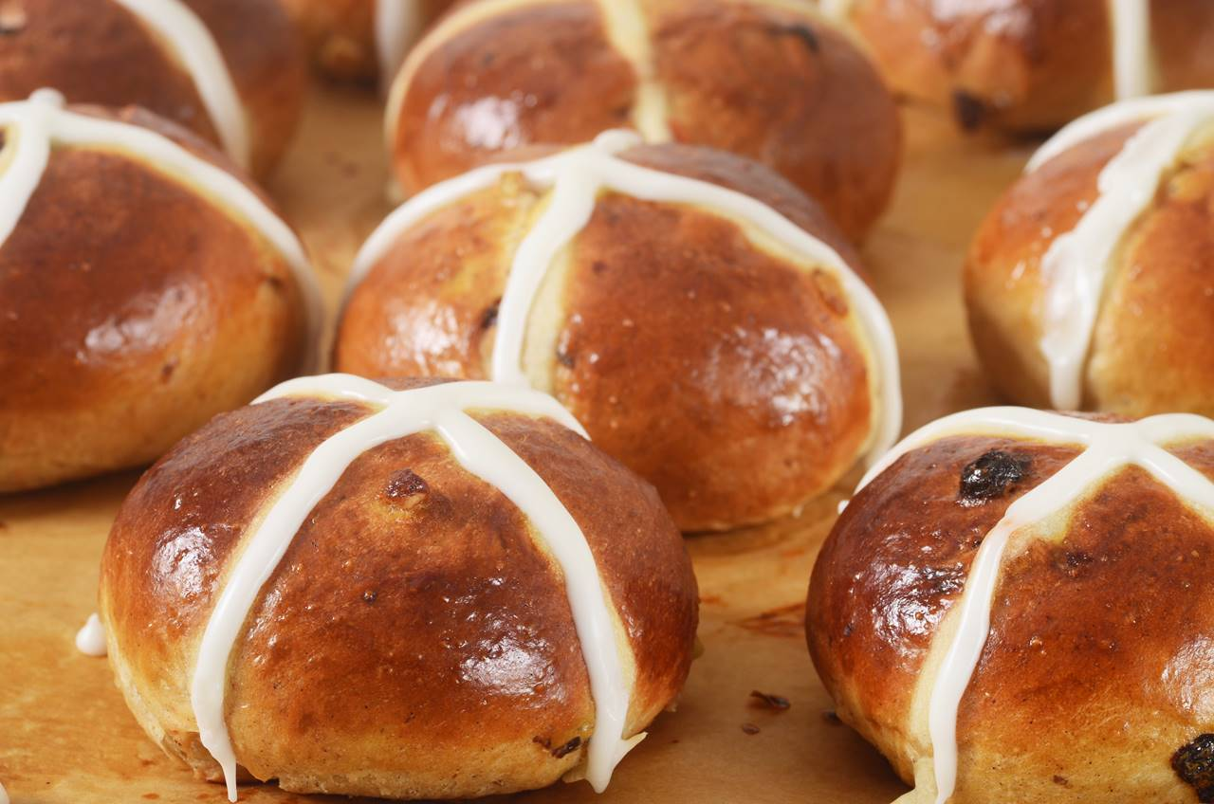

Search the internet for some typical British Easter food and see if you can get an answer.

CHECK FURTHER INSTRUCTION!

In this Easter week, you can (choose one of the options):
- BAKE HOT CROSS BUNS:
- Watch the recipes first:
https://www.youtube.com/watch?v=s59_b993hiI
https://www.youtube.com/watch?v=FmI98uLoRaM
- Choose one recipe and check if you have all the ingredients at home (in the Jamie Oliver recipe, you can leave out chocolate, and in the other recipe you can do the same with dried fruits).
- Follow the recipe and make hot cross buns. Take some pictures during the baking and of your hot cross buns and send them to polona.zavrsnik@os-franaerjavca.si

- WRITE A RECIPE:
- Choose one of the traditional Slovenian Easter dishes and write a recipe.
- Include pictures/drawings – be creative (think of the unit Food we did at school and use the vocabulary that you learnt in that unit).
- Send the project to polona.zavrsnik@os-franaerjavca.si

Because I know that you all work hard and I wanted to show you that I miss you, I am sending you a link to a short video I made. Hope you like it!

https://youtu.be/wN650hlRiQ4

Your teacher Polona

