English, 6. B, 30. 3. 2020 to 3. 4. 2020

MONDAY, 30rd March 2020

THE AIM OF THIS WEEK’S LESSONS (cilji tega tedna):
- to write about what is happening at the moment of speaking (napisati povedi o tem, kaj počneš v trenutku govorjenja),
- describe a photo (opisati fotografijo),
- describe and recognize a person in a photo (opisati in prepoznati ljudi na fotografiji),
- understand a text and find information about it (razumeti besedilo in najti informacije o besedilu).

Are you ready?
Today, we are going to go and travel through space (=vesolje)!
Open your students books on page »v«, chapter S3 AT HOME.
- Read the words in 1-9. Write the title AT HOME and write the words in your notebook. Translate them in Slovene.
Preberi si besede od 1-9.
V zvezek napiši naslov AT HOME (doma). Izpiši si besede
in jih prevedi v slovenščino. Rešitve najdeš na
naslednji strani dokumenta.

1. make her bed = postlati posteljo
2. dance
3. fly
4. talk to
5. cook
6. work
7. watch TV
8. listen to music
9. tidy up

Exercise 2a: Read the dialogues. Look at the picture. Who is Miss Cassie talking to? Check the answers.
Naloga 2: preberi dialoge. Oglej si sliko. S kom govori Miss Cassie? Preveri odgovore.
Now, look at the words written in bold in exercise 2a. How do we call this tense?
Poglej si odebeljene besede v dialogu. Kako imenujemo ta čas?

V zvezku si še enkrat preberi kdaj uporabljamo čas “present continuous”.

TUESDAY, 31rd March 2020
Najprej ponovimo glagol biti.
Kakšne so oblike glagola biti? Kakšne so skrajšane oblike glagola biti?
I AM ‘M
he/she/it IS ‘S
we/you/they ARE ‘RE

Čas present continuous je sestavljen iz treh delov. Najprej uporabljamo glagol biti.

am
is
are

Nato uporabimo glagol (cook, dance, tidy up …).

am
is glagol
are

Glagolu dodamo še tretji del: končnico –ing.

I am
- ing
he/she/it is glagol
we/you/they are

Kako izgleda stavek, ko opisujemo kaj počnemo v tem trenutku:
I am reading (read + ing).
ALI s skrajšano obliko:
I’m reading.

PAZI NA IZJEME PRI ZAPISU, KO GLAGOLU DODAMO KONČNICO -ING:
Nekaterim glagolom ne dodamo samo končnice –ing. To so izjeme:
Glagoli, ki se končajo na –e: make – making
Kratki glagoli, zadnja črka soglasnik, predzadnja samoglasnik (sit, swim, put, get ...): sit – sitting, swimming,
Glagoli, ki se končajo na –l: travel – travelling
Glagoli, ki se končajo na –ie: die – dying, lie - lying

V delovnem zvezku na strani “v” reši nalogo 1 in 2a (glagolom iz prve naloge dodaj končnico –ing) in 2b (razdeli glagole iz naloge 2a v tabelo:
- Glagoli, ki jim samo dodamo končnico –ing
- Kratki glagoli, zadnja črka soglasnik, predzadnja samoglasnik
- Glagoli, ki se končajo na –e)

ANSWER KEY

STUDENT BOOK PAGE V

Exercise 1

1. make her bed = postlati posteljo
2. dance = plesati
3. fly = leteti
4. talk to = pogovarjati se z
5. cook = kuhati
6. work = delati
7. watch TV = gledati televizijo
8. listen to music = poslušati glasbo
9. tidy up = pospraviti

Exercise 2
1. Goss
2. Max
3. Jenna
4. Vorik
5. Inga
6. Delta

Ta čas imenujemo present continuous.
Pri preverjanju rešitev bodi zelo natančen. Pazi na vsako črko, saj je zapis zelo pomemben. Pri tej domači nalogi vzemi rdeč kemik in preveri res vsako črko.
WORKBOOK PAGE V
Exercise 1
2 climb
3 play basketball
4 watch TV
5 draw
6 ride a bike
7 speak Chinese
8 write
9 walk
10 swim
11 sing
12 rollerblade

Exercise 2a
2 climbing
3 playing basketball
4 watching TV
5 drawing
6 riding a bike (brez črke e)
7 speaking Chinese
8 writing (brez črke e)
9 walking
10 swimming (črka m se podvoji, glagol je kratek, zadnja črka soglasnik, predzadnja pa samoglasnik)
11 singing
12 rollerblading (brez črke e)

Exercise 3
Add –ing  (dodamo –ing) | climbing, playing, watching, drawing, speaking, walking, singing
Double the consonant and add –ing  (podvojimo soglasnik in dodamo –ing) | swimming
Take off the –e and add –ing  (odvzamemo –e in dodamo –ing) | riding, writing, rollerblading

THURSDAY, 2nd April 2020
V zvezku še enkrat preberi vse kar smo zapisali o tem kdaj uporabljamo čas present continuous.
Poglejmo kako zanikamo stavke v času present continuous.
Nikalna oblika (negative form):
am, is, are + NOT + glagol –ING
Ednina |  | množina
I | 'm not doing | we | aren't doing
you | aren't doing | you | aren't doing
he/she/it | isn't doing | they | aren't doing

In your notebooks, write down or copy the next page. Do the exercises. Check the answers. Check every letter (preveri vsako črko).

V zvezke prepiši spodnje naloge oziroma jih kopiraj. Reši. Preveri s pomočjo rešitev.

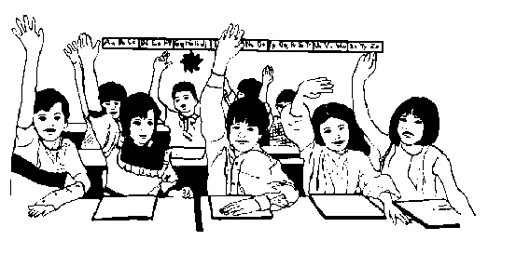
Present continuous

1. Add the ending –ing. Dodaj končnico –ing.

a) sit sitting
b) shop_____________
c) smile ____________
d) stop _____________
e) run _____________
f) ask ______________
g) make ____________
h) bake ____________
i) ride ______________
j) sleep ____________
k) win _____________
l) lift ______________
m) play ____________
n) sing _____________
o) help _____________
p) get ______________
r) leave ____________
s) cry ______________
t) drive _____________
u) die ______________
v) lie ______________

2. Form affirmative (+) or negative (-) sentences. Tvori trdilne ali nikalne povedi. Uporabljaj skrajšano obliko glagola biti.

(+) | (-)
He's snoring. | He isn't snoring.
She's helping him.
Carol's teaching me.
 | Wendy isn't resting.
You're jogging.
 | They aren't talking.

3. Form affirmative (+) or negative (-) sentences. Tvori trdilne in nikalne povedi. Uporabljaj skrajšano obliko glagola biti.

a) (+) I’m writing (write) a postcard at present.
(-) I'm not writing a postcard at the present.
b) (+) They _______________________ (lie) on the floor now.
(-) They ________________________________________.

c) (+) We _______________________ (watch) the news now.
(-) We ___________________________________________.

d) (+) You _______________________ (shop) today.
(-) You ________________________________________.

e) (+) Look! They _______________________ (run).
(-) _____________________________________________.

Present continuous

1. Add the ending –ing. Dodaj končnico –ing.

a) sit sitting
b) shop shopping
c) smile smiling
d) stop stopping
e) run running
f) ask asking
g) make making
h) bake baking
i) ride riding
j) sleep sleeping
k) win winning
l) lift lifting
m) play playing
n) sing singing
o) help helping
p) get getting
r) leave leaving
s) cry crying
t) drive driving
u) die dying
v) lie lying

2. Form affurmative (+) or negative (-)sentences. Tvori trdilne ali nikalne povedi. Uporabi skrajšane oblike glagola.

(+) | (-)
He's snoring. | He isn't snoring.
She's helping him. | She isn’t helping him.
Carol's teaching me. | Carol isn’t teaching me.
Wendy’s resting. | Wendy isn't resting.
You're jogging. | You aren’t jogging.
They’re talking. | They aren't talking.

3. Make affirmative and negative sentences. Tvori trdilne in nikalne povedi. Uporabljaj skrajšano obliko glagola biti.

a) (+) I _______________________ (write) a postcard at present.
(-) I'm not writing a postcard at the present.
b) (+) They are lying (lie) on the floor now.
(-) They aren’t lying on the floor now.

c) (+) We are watching (watch) the news now.
(-) We aren’t watching the news now.

d) (+) You are shopping (shop) today.
(-) You aren’t shopping today.

e) (+) Look! They are running (run).
(-) They aren’t running.

FRIDAY, 3nd April 2020
- In your student book page “vi”, do exercises 3a and 4a. Check the answers.

- Choose your own photograph or any photo in a magazine or in your student book.
Write ten sentences about what is happening in the photo.
Write 5 things that aren’t happening in the photo.
Use present continuous: mark the tense red.
Send the homework together with the photo to valentina.batagelj@os-franaerjavca.si until Tuesday, the 7th of April 2020. Don’t forget to write your name and your surname.
Follow my example. I am already looking forward to seeing your photos.

Izberi svojo fotografijo ali fotografijo iz revije ali učbenika. Napiši 10 povedi o tem, kaj se dogaja na fotografiji. Zapiši pet stvari, ki se na fotografiji ne dogajajo.
Uporabi čas present continuous in ga obarvaj z rdečo. Nalogo lahko narediš v zvezek in stran fotografiraš/skeniraš.
Pošlji domačo nalogo skupaj s fotografijo na elektr. naslov valentina.batagelj@os-franaerjavca.si do torka, 7. aprila 2020. Ne pozabi pripisati svojega imena in priimka.
Sledi mojemu zgledu. Se že veselim tvoje fotografije.

They are playing in the nature.
They are making a bridge made of stones.
My daughter is wearing a dress and trousers.
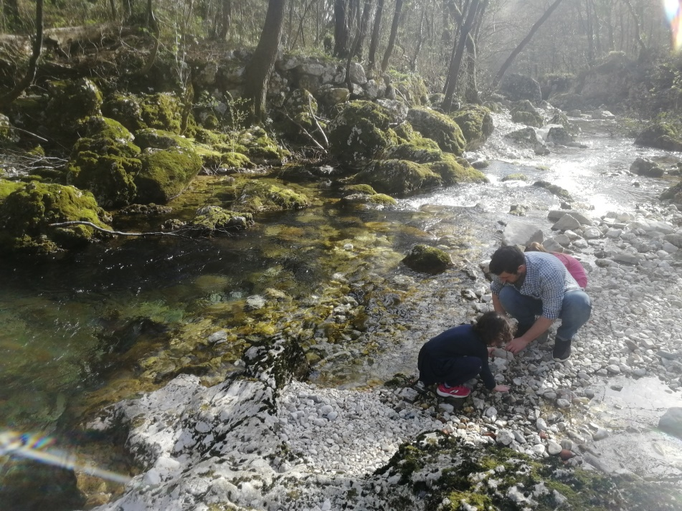
She is singing.
I am taking a photo.
The birds are singing.
The water is running.
The leaves are turning green.
The sun is shining.
The butterflies are flying over the river.

The wind isn’t blowing.
It isn’t snowing.
They aren’t watching TV.
We aren’t spending time with our friends.
She isn’t wearing a T-shirt.

STUDENT BOOK PAGE VI (answer key)

Exercise 3a
- F Max isn’t writing. He is playing basketball.
- T
- F Rex and Tara aren’t playing football. They are watching TV.
- T

Exercise 4a
2. Fento
3. Tilda
4. Yuri and Arak
5. Alf
6. Yip and Yap
7. Kitty
8. Nandi and Deela
9. Jess
10. Rex and Tara

Well done, you have completed all the exercises!
Now look: did you complete the aims of this week?

Zelo dobro: dokončal si vse naloge!
Sedaj preveri: si dosegel vse cilje v tem tednu?

Če o čemerkoli nisi prepričan mi piši na valentina.batagelj@os-franaerjavca.si.

