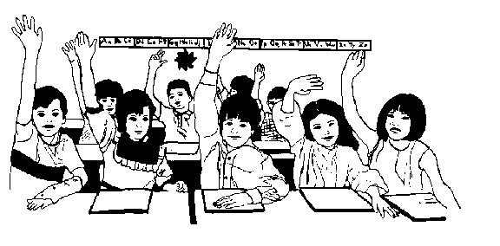
Present continuous

1. Add the ending –ing. Dodaj obrazilo –ing.

a) sit ______________
b) lie ______________
c) die ______________
d) stop ______________
e) run ______________
f) ask ______________
g) make ______________
h) bake ______________
i) ride ______________
j) sleep ______________
k) win ______________
l) lift ______________
m) play ______________
n) sing ______________
o) help ______________
p) get ______________
r) leave ______________
s) cry ______________
t) drive ______________
u) smile ______________
v) shop ______________

2. Form affermative (+), negative (-) and interrogative sentences. Tvori trdilne, nikalne in vprašalne povedi.
(+) | (-) | (?)
He's snoring. | He isn't snoring. | Is he snoring?
She's helping him.
 |  | Are they studying?
Carol's teaching me.
 | Wendy isn't resting.
 |  | Is she making the bed?
You're jogging.
 | They aren't talking.
 |  | Are you flying now?

3. Make affirmative, negative and interrogative sentences.
a) (+) I _______________________ (write) a postcard at present.
(-) I'm not writing a postcard at the present.
(?) Are you writing a postcard at present?

b) (+) They _______________________ (lie) on the floor now.
(-) They ________________________________________.
(?) ____________________________________________?

c) +) We _______________________ (watch) the news now.
(-) We ___________________________________________.
(?) ______________________________________________?

d) (+) She _______________________ (do) the washing up at the moment.
(-) She ________________________________________.
(?) ___________________________________________?
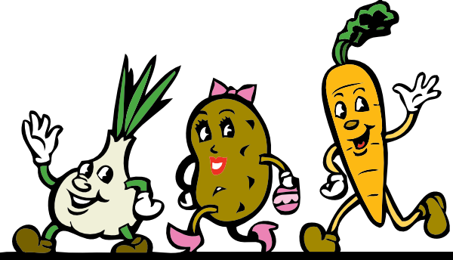
e) (+) You _______________________ (shop) today.
(-) You ________________________________________.
(?) ____________________________________________?

f) (+) Look! They _______________________ (run).
(-) _____________________________________________.
(?) _____________________________________________?
g) (+) I _______________________ (try) to help you at present.
(-) I ____________________________________________.
(?) _____________________________________________?

4. Make these sentences interrogative. Tvori vprašalne povedi.
a) You're stopping your car. Are you stopping your car?
b) We're riding a motorbike now. __________________________________?
c) Doris is playing the guitar. __________________________________?
d) She's practising golf at present. __________________________________?
e) They are helping their parents. __________________________________?

5. Make these sentences negative. Tvori negativne povedi.
a) He's drinking wine now. He isn't drinking wine now.
b) They're eating vegetables at the moment. _________________________________.
c) Mary's resting now. _________________________________.
d) I'm having a shower at the moment. _________________________________.
e) He's ringing the bell now. _________________________________.

6. Form Present Continuous. Tvori opisni sedanjik.
0. We __are sitting__ in the living room now. (sit)
1. She ___________________ a bath now. (have)
2. I ___________________ my bed now. (make)
3. I ___________________ to you, Mary. (talk)
4. Why ____ you ______________ to him? (listen)
5. ______ you ______________ the game? (lose)
6. I ______________ the window. (open)
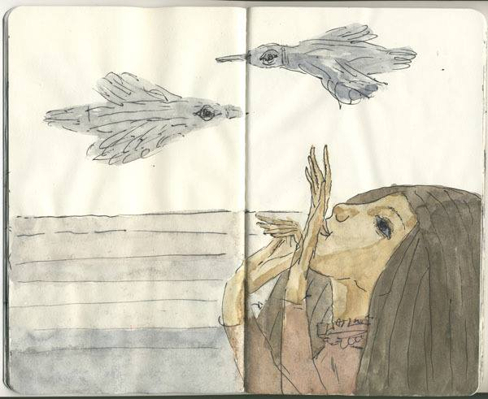
7. Form short answers. Tvori kratke odgovore.
0. Are you working? ____Yes, I am. / No, I’m not.___
1. Is Tom winning the game? No, ________________________
2. Are they hiding? Yes, _______________________
3. Are the birds flying? Yes, _______________________
4. Is the alarm clock ringing? Yes, _______________________
5. Are they going to the cinema? No, ________________________

8. Translate. Prevedi
1. Ona se uči v tem trenutku. ____________________________________________.
2. John in Mike iščeta zvezek. ____________________________________________.
3. Ali imate sedaj kosilo? ____________________________________________.
4. Mi čakamo na film. ____________________________________________.
5. Peter prižiga luč. ____________________________________________.
6. Mickey in Millie gresta v park. ____________________________________________.

9. Imagine it is Saturday. It is raining. You call your best friend. Write down five questions to ask what s/he is doing.
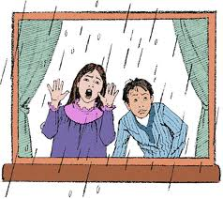
Are you eating breakfast? _________________________________ _______________________________________________________ _______________________________________________________
_______________________________________________________

