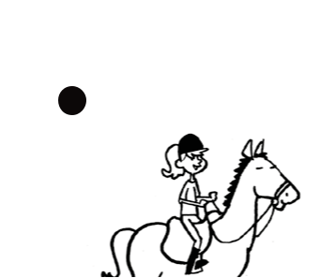
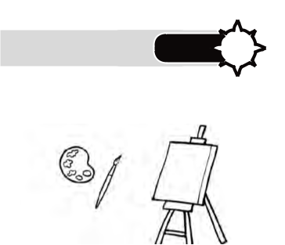
Reinforcementi 2? Unit 2?

- Write.
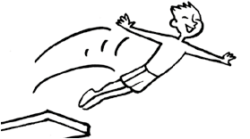

1 | 2 |  | 3 |  | a
a |  |  |  |  | n
deri
srohe | v | d |  | i | p
 | e | i
t
ride a horse
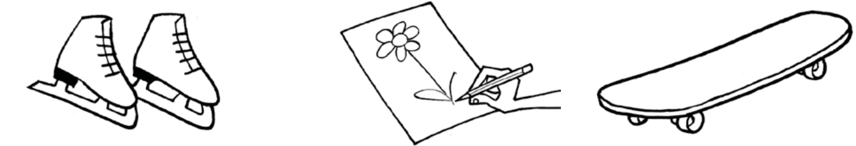

4 |  | 5 |  | 6 |  | d | r |  |  | t
k | t | w | d |  | a
 |  |  | r |  |  |  | a | k |  | e
 | e | a |  |  |  | b |  |  |  | o
s |  |  | a |  |  |  |  |  | s
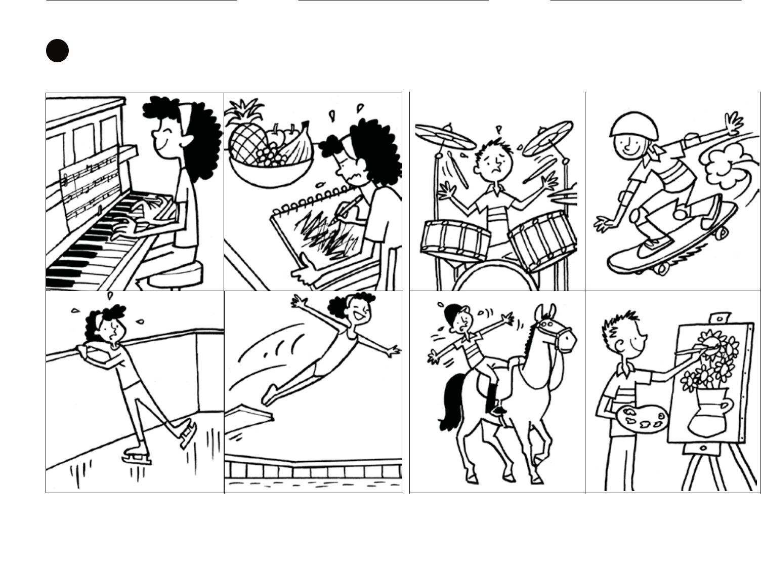

- Look and write. Use can or can’t.

 | Amanda |  |  |  | Tommy
1
 |  | 2 |  | 5 |  | 6

3 | 4 | 7 | 8

1 | She can play the piano. | 5 | He
2 |  | 6
3 |  | 7
4 |  | 8

Photocopiable © Oxford University Press E XPLO RERS 1 5

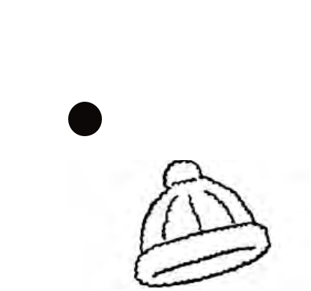
Reinforcement 1? Unit 3?

- Complete. Find and circle.

1 |  |  |  |  |  |  |  |  |  |  |  |  |  |  |  |  |  |  |  |  |  |  |  |  |  |  |  | 5 |  |  |  |  |  |  |  |  |  |  |  |  |  |  |  |  |  |  |  |  |  |  |  |  |  |  |  |  |  |  |  | o
 |  |  |  |  |  |  |  |  |  |  |  |  |  |  |  |  |  |  |  |  |  |  |  |  |  |  |  |  |  |  |  |  |  |  |  |  |  |  |  |  |  |  |  |  |  |  |  |  |  |  |  |  |  |  |  |  |  |  | s | r | f
w o o l l y h a t |  |  |  |  |  |  |  |  |  |  |  |  |  |  |  |  |  |  |  |  |  |  |  |  |  |  |  | s |  |  |  |  |  |  |  |  |  |  |  | g l |  |  |  |  |  |  |  |  | s s |  |  |  |  |  |  |  | n | j | a | a | n | t | r
 |  |  |  |  |  |  |  |  |  |  |  |  |  |  |  |  |  |  |  |  |  |  |  |  |  |  |  |  |  |  |  |  |  |  |  |  |  |  |  |  |  |  |  |  |  |  |  |  |  |  |  |  |  |  |  | r | a | i | n | c | o | a | t | d
2 |  |  |  |  |  |  |  |  |  |  |  |  |  |  |  |  |  |  |  |  |  |  |  |  |  |  |  | 6
 |  |  |  |  |  |  |  |  |  |  |  |  |  |  |  |  |  |  |  |  |  |  |  |  |  |  |  |  |  |  |  |  |  |  |  |  |  |  |  |  |  |  |  |  |  |  |  |  |  |  |  |  |  |  |  | i | t | z | d | c | u | p | t | j
 |  |  |  |  |  |  |  |  |  |  |  |  |  |  |  |  |  |  |  |  |  |  |  |  |  |  |  |  |  |  |  |  |  |  |  |  |  |  |  |  |  |  |  |  |  |  |  |  |  |  |  |  |  | e |  | i | f | p | a | g | l | o | v | e | s
r |  |  |  |  |  |  |  |  |  |  | n c |  |  |  |  |  |  |  |  |  |  |  |  |  | t |  |  | s |  |  |  |  |  |  |  |  |  |  |  |  |  |  |  |  |  | f |  |  |  |  |  |  |  | s |  | u | n | g | l | a | s | s | e | s | i
3 |  |  |  |  |  |  |  |  |  |  |  |  |  |  |  |  |  |  |  |  |  |  |  |  |  |  |  | 7 |  |  |  |  |  |  |  |  |  |  |  |  |  |  |  |  |  |  |  |  |  |  |  |  |  | s |  | w | i | m | s | u | i | t | j | e | r
 |  |  |  |  |  |  |  |  |  |  |  |  |  |  |  |  |  |  |  |  |  |  |  |  |  |  |  |  |  |  |  |  |  |  |  |  |  |  |  |  |  |  |  |  |  |  |  |  |  |  |  |  |  |  |  | l | p | j | e | a | n | s | e | t
 |  |  |  |  |  |  |  |  |  |  |  |  |  |  |  |  |  |  |  |  |  |  |  |  |  |  |  |  |  |  |  |  |  |  |  |  |  |  |  |  |  |  |  |  |  |  |  |  |  |  |  |  |  |  |  | w | o | o | l | l | y | h | a | t
s w |  |  |  |  |  |  |  |  |  |  |  |  |  | s u |  |  |  |  |  |  |  |  |  | t |  |  |  | j |  |  |  |  |  |  |  |  |  |  |  |  |  |  |  |  | s
 |  |  |  |  |  |  |  |  |  |  |  |  |  |  |  |  |  |  |  |  |  |  |  |  |  |  |  |  |  |  |  |  |  |  |  |  |  |  |  |  |  |  |  |  |  |  |  |  |  |  |  |  |  |  |  |  | i | s | c | a | r | f | s
4 |  |  |  |  |  |  |  |  |  |  |  |  |  |  |  |  |  |  |  |  |  |  |  |  |  |  |  | 8
 |  |  |  |  |  |  |  |  |  |  |  |  |  |  |  |  |  |  |  |  |  |  |  |  |  |  |  |  |  |  |  |  |  |  |  |  |  |  |  |  |  |  |  |  |  |  |  |  |  |  |  |  |  |  |  |  |  |  | r | y | v
 |  |  |  |  |  |  |  |  |  |  |  |  |  |  |  |  |  |  |  |  |  |  |  |  |  |  |  |  |  |  |  |  |  |  |  |  |  |  |  |  |  |  |  |  |  |  |  |  |  |  |  |  |  |  |  |  |  |  |  | j
s |  |  |  |  |  |  |  |  |  |  | d |  |  |  |  |  |  |  |  |  |  |  |  |  |  |  |  | g l
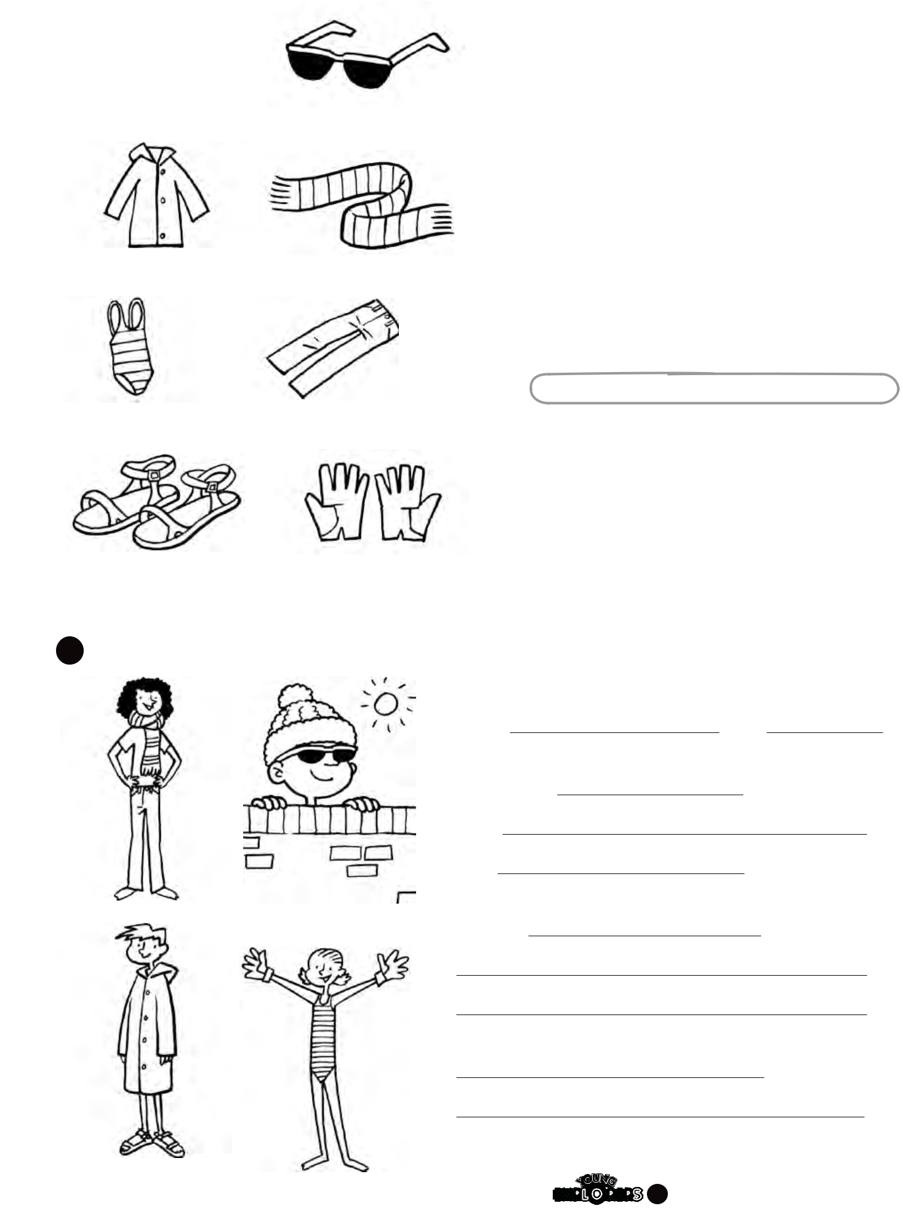

- Look and write.
1 | 2 | 1 What’s | she wearing?

She’s wearing jeans and a scarf.

- What’s he He’s and

₃ ₄ 3 What’s

4

Photocopiable © Oxford University Press E XPLO RERS 1 7

