CLOTHES
Ko nalogo končaš mi delovni list lahko pošlješ na e-mail dejan.preradovic@os-franaerjavca.si , da ga pregledam in popravim.

1. Postavi črke v pravilni vrstni red, tako da sestaviš besede za oblačila.

I R A N T R S E __________________________
O E H S S ______________________________
E A J S N _____________________________
I R S H T ______________________________
I N A O R A C T ________________________
K T J C E A _____________________________
L G S V O E _____________________________
S S L G A E S _____________________________
S S S N L U G A E S ___________________________
I R K S T _________________________________
I W S U M I T S ____________________________
S S A A D N L _____________________________
S S O T R H _______________________________
F A R S C _________________________________

2. Kaj imajo osebe na slikah oblečeno? Napiši vprašanje in odgovor.
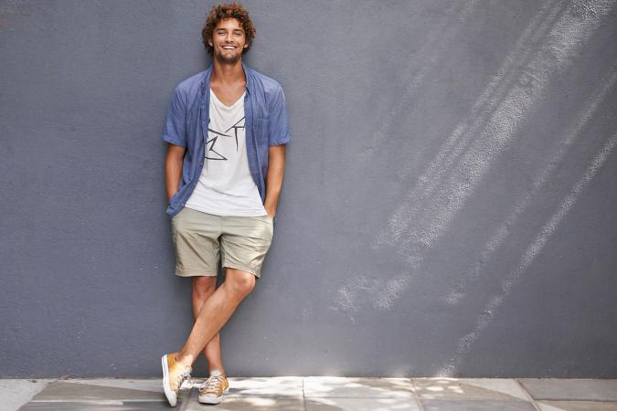
What is _______________________?
_______________________________________________
_______________________________________________
_______________________________________________
_______________________________________________
_ ____________________________________________________





