IN THE JUNGLE
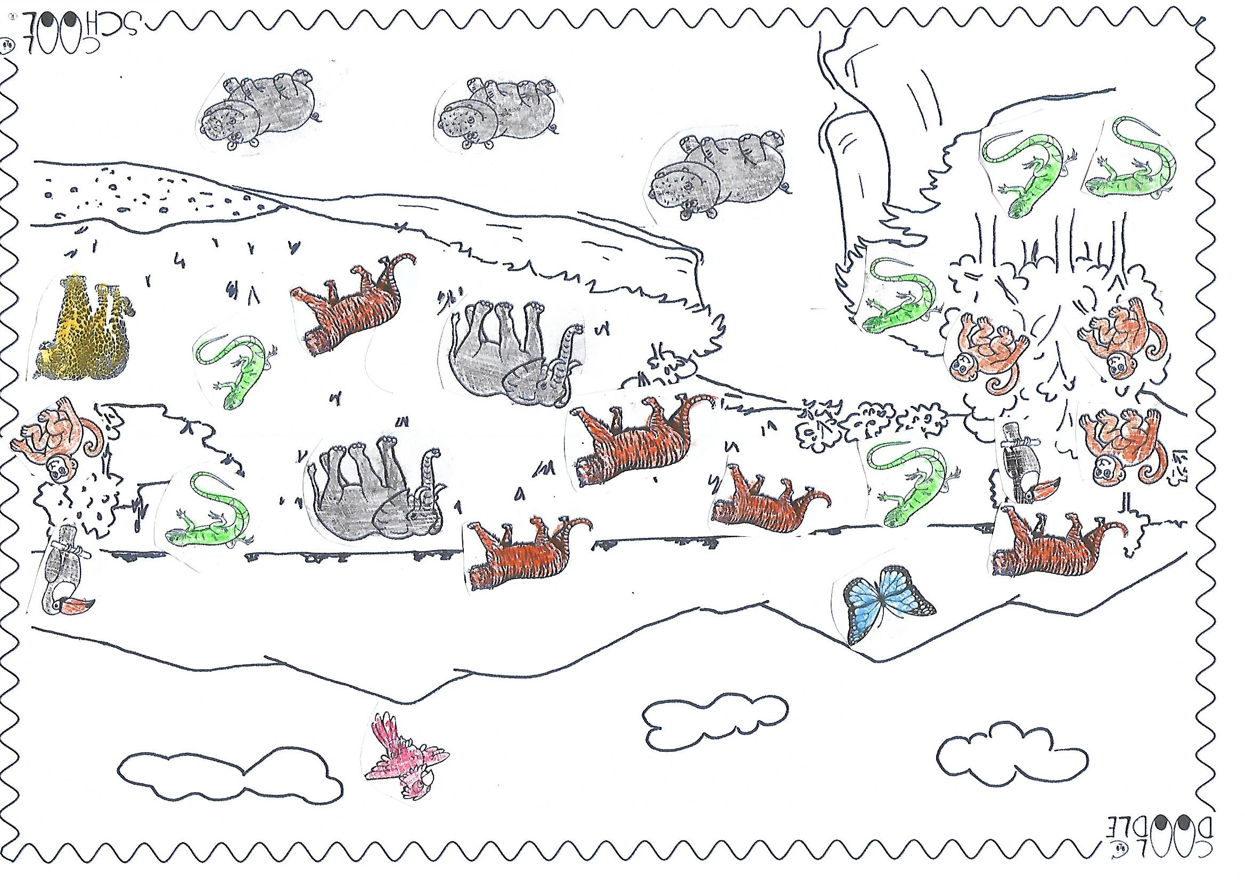
1. Dopolni tabelo
a butterfly a tiger a jaguar an elephant a parrot
a hippo a toucan a lizard a monkey
 | IS / ARE | NUMBER | ANIMAL
THERE

