ZAPIS V ZVEZEK:

**DELI CELOTE**

1. 1m = 100 cm

m = 10 cm, ker je od 100 cm = 10 cm, ker je 100 cm : 10 ∙ 1 = 10 cm

[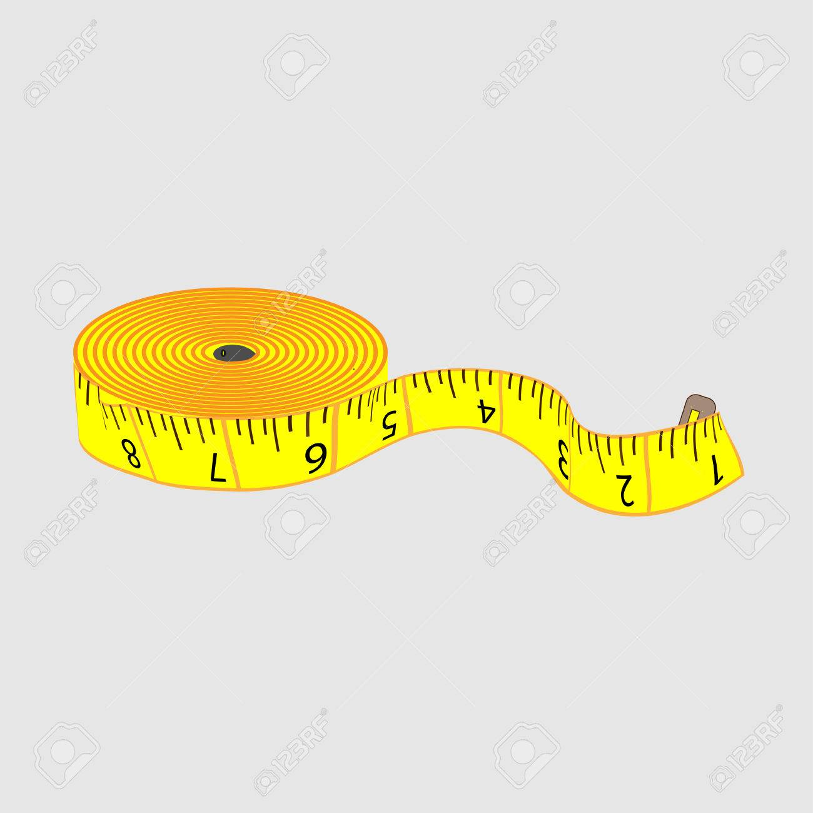](https://www.google.si/url?sa=i&url=https://www.123rf.com/photo_74153574_stock-vector-tailor-meter.html&psig=AOvVaw29Y_OTujwkiZKxdD31OnN5&ust=1589012526801000&source=images&cd=vfe&ved=0CAIQjRxqFwoTCODLvo_ro-kCFQAAAAAdAAAAABAD)

Na kratko:

m = 10 cm, ker je 100 : 10 ∙ 1 = 10

1. 1kg = 1000g

kg = 750 g, ker je od 1000 g = 750 g, ker je 1000 g : 4 · 3 = 250 g · 3 = 750g

[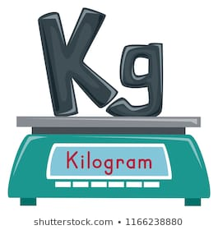](https://www.google.si/url?sa=i&url=https://www.shutterstock.com/search/kilogram&psig=AOvVaw30yLrUB6O2w8e-x2VJIppa&ust=1589012636984000&source=images&cd=vfe&ved=0CAIQjRxqFwoTCLjZg8Pro-kCFQAAAAAdAAAAABAD)

Na kratko:

kg = 750 g, ker je 1000 : 4 · 3 = 250 · 3 = 750

1. 1h = 60 min

h = 30 min, ker je od 60 min = 30 min, ker je 60 min : 2 · 1 = 30min

[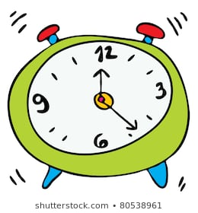](https://www.google.si/url?sa=i&url=https://www.shutterstock.com/image-vector/cartoon-clock-80538961&psig=AOvVaw3TDqDyLJA0FZ0suTLexngz&ust=1589012762219000&source=images&cd=vfe&ved=0CAIQjRxqFwoTCPiMqv3ro-kCFQAAAAAdAAAAABAD)

Na kratko:

h = 30 min, ker je 60 : 2 = 30

1. Reši v zvezek.

|  |  |
| --- | --- |
| m = ____ cm, ker je _______________­­­­­­____  m = ____ cm, ker je _______________­­­­­­____  m = ____ cm, ker je _______________­­­­­­___ | |
| km = ____ m, ker je _______________­­­­­­___  km = ____ m, ker je _______________­­­­­­____  kg = ____ g, ker je _______________­­­­­­____  kg = ____ g, ker je _______________­­­­­­____ | |
| h = ____ min, ker je _______________­­­­­­___  h = ____ min, ker je _______________­­­­­­____ | |

REŠITVE:

 m = 30 cm, ker je 100 : 10 ∙ 3 = 30

 m = 75 cm, ker je 100 : 4 ∙ 3 = 75

 m = 50 cm, ker je 100 : 2 ∙ 1 = 50

 km = 100 m, ker je 1000 : 10 ∙ 1 = 100

 km = 300 m, ker je 1000 : 10 ∙ 3 = 300

 kg = 250 g, ker je 1000 : 4 ∙ 1 = 250

 kg = 50 g, ker je 1000 : 4 ∙ 3 = 750

 h = 30 min, ker je 60 : 2 ∙ 1 = 30

 h = 15 min, ker je 60 : 4 ∙ 1 = 15