LET’S PLAY

1. K vsaki sliki napiši hobi oz. spretnost, ki je na sliki.

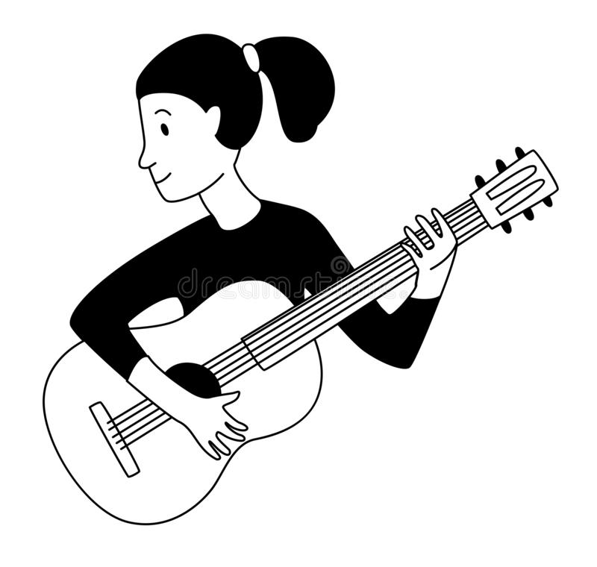________________________ 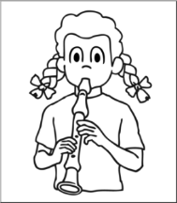____________________________

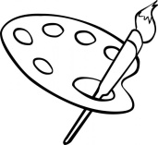______________________ ___________________________

___________________ ___________________________

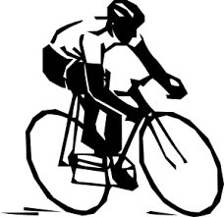______________________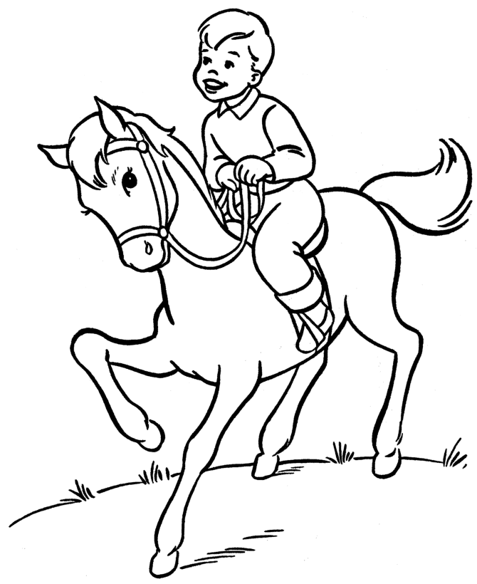______________________________

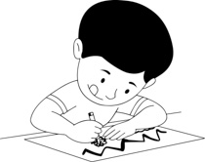(risati) ___________________ 